Credosoft Development Task User Guide

# Running the program

When you run the program for the first time it will automatically generate a database with some default data in order to show the initial workings of the software.

The selected table is shown in a drop-down menu box above the table and the selected table can be changed by using this box

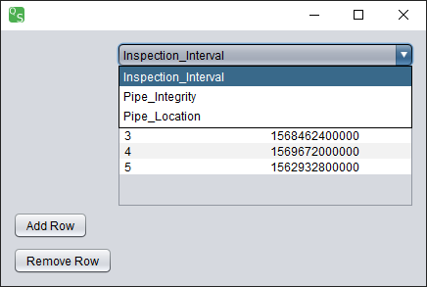When another table is selected the program will grab the data from the table in the database with that name and display it in the table with the correct column names at the top.

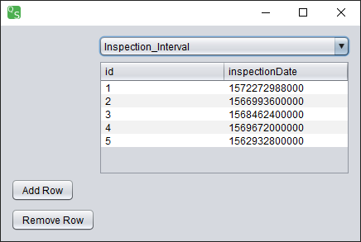At the bottom left of the application window there are two buttons. These buttons are what allow you to add and remove rows from the selected table.

# Adding a Row

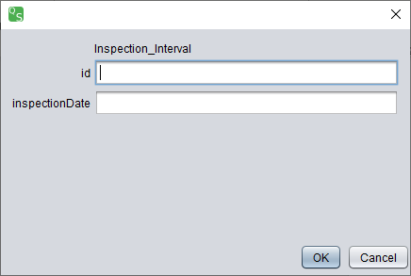To add a row to a specific table you first must select the table you would like to add the row to. When you have done this, click the Add Row button. A new window will appear. This window will display the table you will be adding a row to and will give you text fields to input the data you wish to add to the specified columns. If you discover that this is the wrong table, just click cancel to return to the main window. Once you have entered the data you wish to add, simply click OK to add it to the database table.

# Removing a Row

To remove a row from a specified table, you must select the table from the drop-down menu, then click on the row you wish to delete. From here, simply click the Remove Row button, and the row will be deleted from the table.